

These technical notes are intended for ACE representatives only, to assist in understanding and presenting the ACE philosophy and technical assistance when discussing the ACE products with a client:

ATD-1032 (January 2011) “Flux Applicators”

Gentlemen…
We are often asked “what flux applicators do I need and when do I use them”. Hopefully the following information will clear this up:

“It is a given that residual flux is still ionically and chemically active if it remains on the assembly”.
OVERVIEW:
The use of flux is just as necessary for selective soldering as it is for its cousin, wave soldering; in fact, most of the same flux chemistries are used in both. However, unlike wave soldering, where the entire assembly is subjected to contact with the solder wave, in selective soldering, only specific areas are contacted by molten solder. What many don’t recognize is that all the flux applied to the board may not “see” contact with the solder fountain. This can cause problems later, because that residual flux is still ionically and perhaps chemically active if it remains on the assembly.
For this reason, the selective soldering equipment user has a choice of two types of selective flux applicators: a spray fluxer and/or a dropjet fluxer. The aerosol spray fluxer applies atomized flux to a specific area, while the dropjet fluxer is more precise, and the choice depends on the circumstances surrounding the soldering application.
In either wave or selective soldering, if using a water-based flux, or even an older rosin-based flux, there is probably going to be a post-soldering cleaning operation to remove any flux residues. This cleaning step not only removes residues, but also any potential ionic contamination that might accompany these residues. You’re cleaning the assembly, overall, at the same time. In this scenario, a spray fluxer is appropriate.
No-clean fluxes are an entirely different matter. A no-clean is used expressly to eliminate the cleaning step. No-clean fluxes originally were designed to be used with wave soldering, where the entire board is passed through the wave, and the solder brings all the flux up to a mitigating temperature and removes or scrubs off residues, (hopefully) rendering a post-cleaning operation unnecessary. Any residue on the board is deemed to be non-ionic contaminating.

SPRAY FLUXERS:
Whenever a spray fluxer is used on a selective soldering machine a subsequent post-cleaning operation is needed. Why? In selective soldering, the solder is only contacting a limited area, or a number of select areas, and not the entire board. Consequently, if flux is sprayed outside of the solder contact area, it won’t be heated to an appropriate temperature needed to render it inert, or be removed by immersion into the molten solder, and thus, it will remain ionically active if there is no post-cleaning operation (which there probably would not be if a no-clean flux is used). To re-emphasize….Spray fluxers (aerosol fluxers and this category includes ultrasonic fluxers as the also use air pressure) are fast and low maintenance; however they will create overspray that the solder will not clean off.
Thus, when a no-clean flux is used, we suggest dropjet fluxing instead of spray fluxing. The dropjet fluxer puts down a tiny amount of flux in a very closely-defined location (think ink-jet). It does this through positive displacement, not aerosol, technique. Dropjet fluxers are programmable, permitting a select amount of flux, one droplet or a multitude as required, or even a continuous line of flux. The deposition can be controlled down to a 1mm diameter flux droplet on the pad and the pin, where it’s needed.

DROP JET FLUXERS:
With the DJ the goal is to apply only the minimal amount of flux necessary to achieve the class 3 solder joint without any excess. The other major part of the process is to have the solder engulf that entire deposited amount of no-clean flux and wash it off with the scrubbing action of the flowing molten solder, just as a solder wave would in a wave soldering machine. This makes post-cleaning unnecessary and prevents ionic contamination problems.
The Drop Jet is slower than the spray applicator. As an example, a dual row connector with 128 pins will be fluxed in approximately 2 seconds with the KFS-Spray and 3-4 seconds with the KFS-DJ. However, fluxing is a very rapid segment of the process. Usually the soldering segment takes 4-6 times as long as the fluxing. A board that takes a total of 5 minutes to process will have 20-30 seconds for spray fluxing or 40-60 seconds for the DJ fluxing. Another benefit of the DJ is “penetration” of the flux through the barrel. The shear force of the impact usually will force the flux to the top side of the board which paves the way for good barrel fill and good top side fillets.

ACE is unique in that we build our own DJ right in the ACE manufacturing facility. We have design and quality control that no other selective soldering vendor can claim. In fact, ACE bought Castle Controls in 2007, at that time made the DJs for Ersa and other vendors). Our DJs will out perform any other suppliers in ease of use, serviceability and solid content (ours will handle up to 30% while others claim limitations of less than 5%).
We see many Customers configuring the KISS machines with dual applicators as seen below.
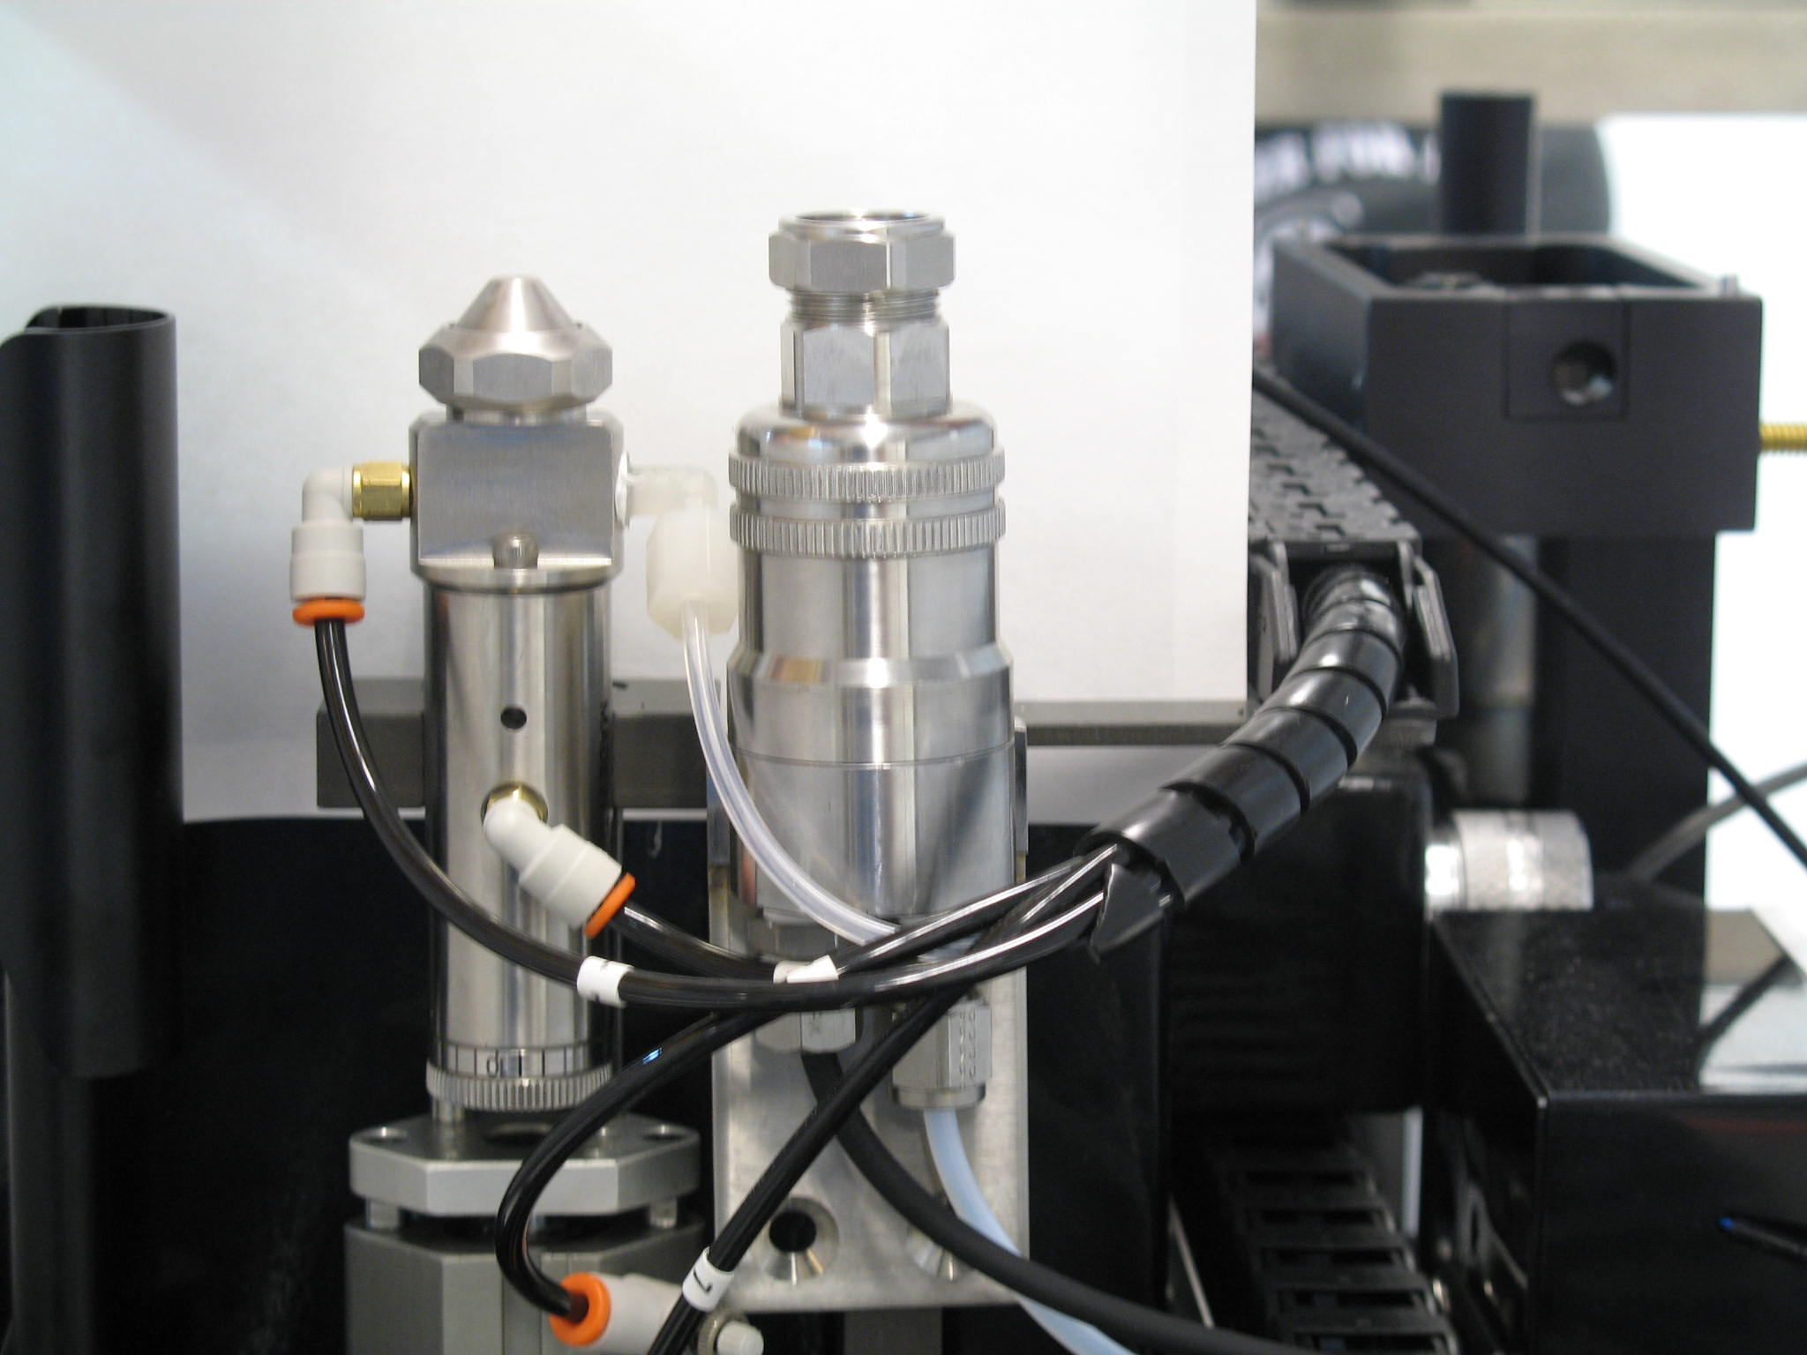

Hope this helps..........

Alan Cable

Alan Cable

A.C.E. Production Technologies, Inc.
3010 N. First St..
Spokane Valley, WA 99216
Office: 509-924-4898
Cell: 509-993-6571
mailto:acable@ace-protech.com
ace-protech.com

